ConfMS is an application that allows you to create and manage conferences. Here you can upload information about your conference and anyone who is interested can join it.

For those who are into research and want to share their knowledge, this app will help them find the conferences suitable for their papers.

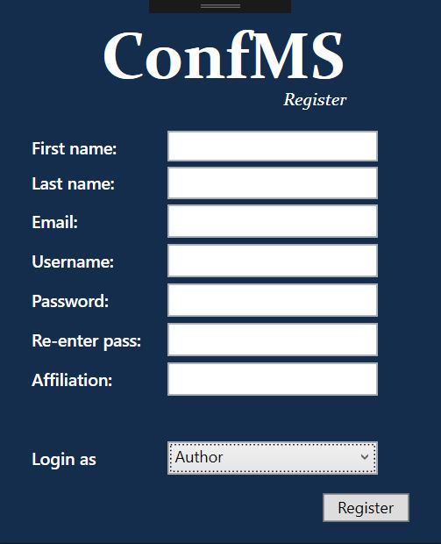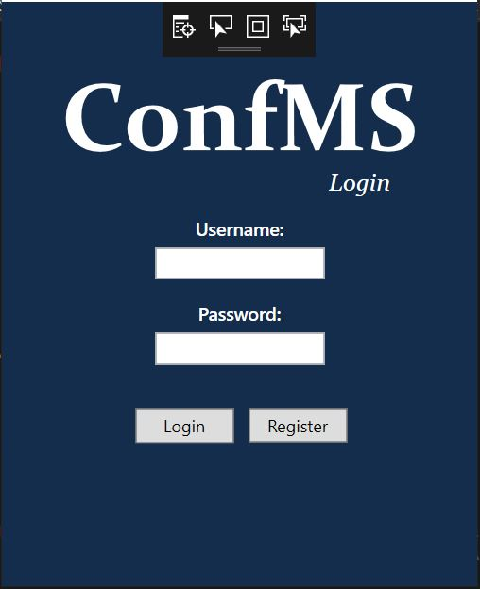

*The start page The register page*

**The regular user:**

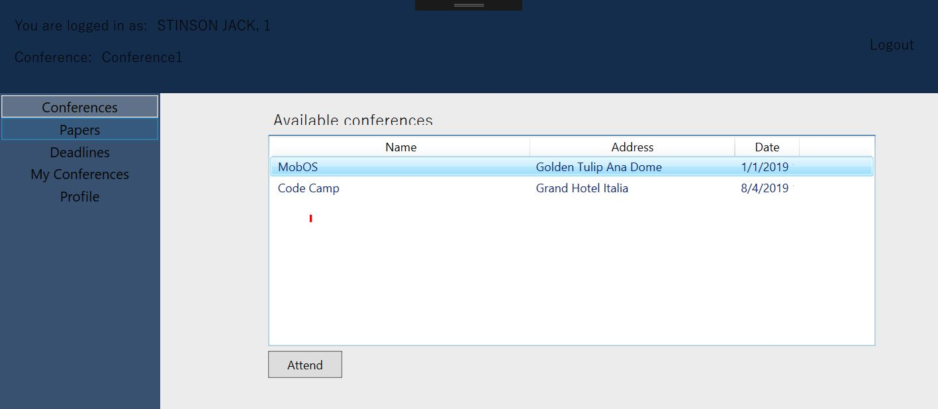Anyone can create an account as a regular user (listener). This user role allows you to see the upcoming conferences and join them.

*All conferences page*

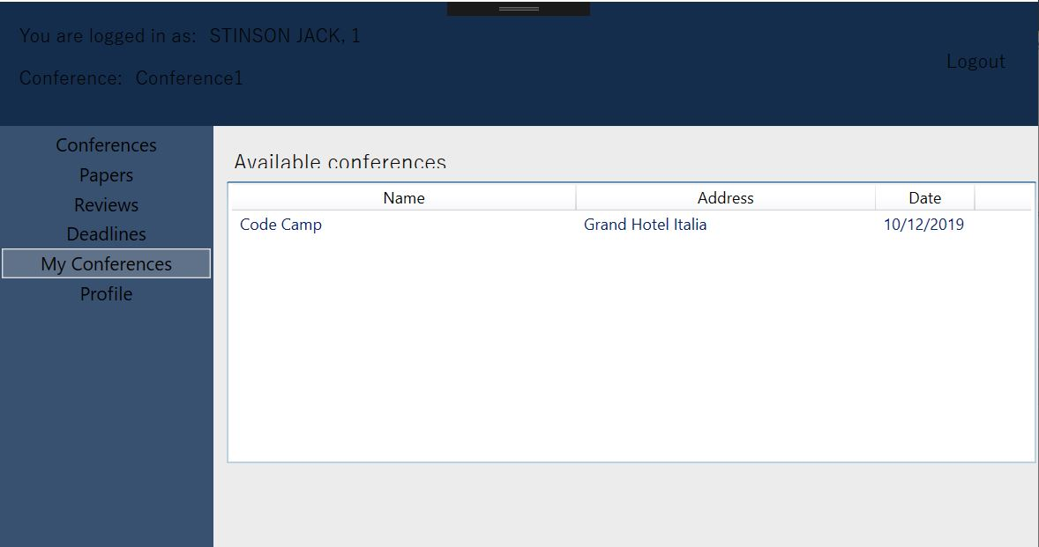

*The conferences this user has chosen to attend*

**The author:**

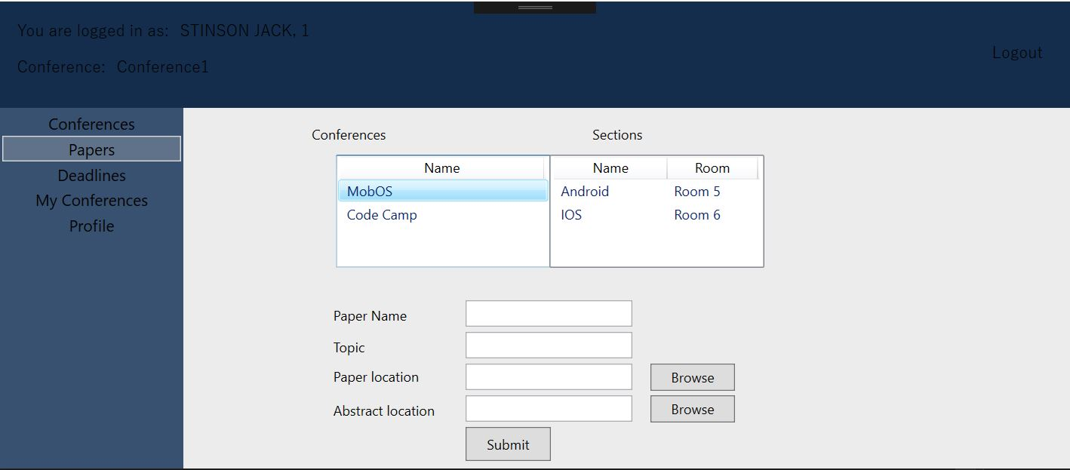Apart from seeing and attending conferences, an author can also submit papers by submitting a paper or an abstract.

*Here, the author can submit a paper*

**Program Committee Member:**

This is a special role, meaning that only those who have already been chosen in the program committee can create an account as a PC Member. This role gives you the possibility to also change (postpone) deadlines.

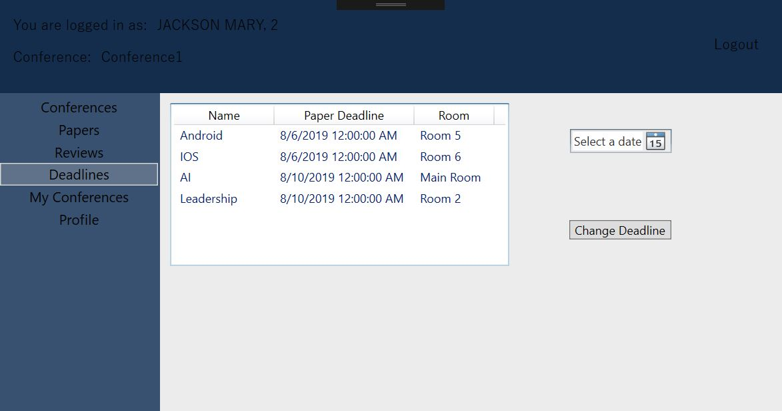

*Deadlines page*